TEASLES PET GROOMING SERVICE

Phoenix Rising Inc.

Team 4

**TABLE OF CONTENTS**

Executive Summary……………………………………………3

Member Introductions………………………………………….4

Client Introduction………………………………………………5

Current Situation………………………………………………..6

Database System ERDs……………………………………….7

Logical Relational Schema…………………………………….8

Data Tables……………………………………………………...9

Queries/Results…………………………………………………10-14

Issues/Quirks/Challenges………………………………………15

Lessons Learned………………………………………………..16

Appendices

A…………………………………………………………..17-25

B…………………………………………………………..26-33

**EXECUTIVE SUMMARY**

Teasles is a premium pet grooming salon located in Lexington, Nebraska. Over the course of the previous five years, Teasles has developed a solid consumer base which is expanding in scope and magnitude. Naturally, a need to establish and improve a database management system for the optimal categorization of employees, clients, pets, and services has since developed. Phoenix Rising Inc. has designed a scheme to satisfy this demand.

The database design accurately sectionates employee affairs, pets and services, and client information while also integrating them easily. As a result of our efforts, Teasles can now manage its business and perform queries of relevant data with promising simplicity. Questions such as which employees earn above average salary, which clients haven’t been seen in a year, and how many German Shepherds are in the care of Teasles, are now easily answered. In addition, the exodus from paper-format into the digital plane has now all but assured data will be preserved for years to come.

**MEMBER INTRODUCTIONS**

**Darvyn Jean-Baptiste** - Data analyst. Darvyn helped convert data and build the overall framework for the database. Focused on defining and compacting the Employee information.

**Marco De Los Santos** - Data translator. Marco helped establish ERDs and generated data for the tables. Handled the Appointment and Services information to pull up service codes with ease.

**Guilherme Osario** - Data analyst. Guilherme helped write queries and tested the logical relationships in the database. Took care of the Client and Pet information and made sure breeds and weights made sense.

Each member contributed to the visualization, logical schema, final report and presentation of the database.

**CLIENT INTRODUCTION**

Teasles is a pet grooming salon located in Lexington, Nebraska. Currently with ten full-time employees, two part-time employees and a growing consumer base; Teasles has a demand for database management services. Phoenix Rising Inc. has agreed to build a system for Teasles to accommodate their needs. Diane and Jennifer Hearst, owner of the salon, have been experiencing trouble managing their administrative duties due to a lack of data resources and an antiquated paper-file system. With their new computer and copy of Microsoft SQL Server, Teasles is ready to work with Phoenix Rising Inc. to get their database up and running like professionals.

**CURRENT SITUATION**

In the current situation, Teasles has a paper filing system that is poorly managed and organized. This is causing the owners, Diane and Jennifer, much grief. They have purchased a state-of-the-art computer with Microsoft SQL Server to convert their file cabinet into an online database. Phoenix Rising Inc. has agreed to do the job. A system has to be installed that will help tally the clients and their pets. Pet information, for example, will have important demographic data such as gender, weight, and breed which will be useful for future analysis. Alongside this, employee information has to be managed properly to account for changes in work schedule and salary payments which must account for deductions. Each employee has classifiers unique to them such as SSN and contact information but they can also have similar inputs like first name and title that must be accounted for. Finally, Teasles needs a system that organizes the appointments for the pets, delineates the types of services conducted in every appointment, whether there was walk-in service or not, and whether a pet was turned down due to lack of vaccination. The system in place must also be simple enough to input new items and query facts with ease.

**DATABASE SYSTEM ERDs**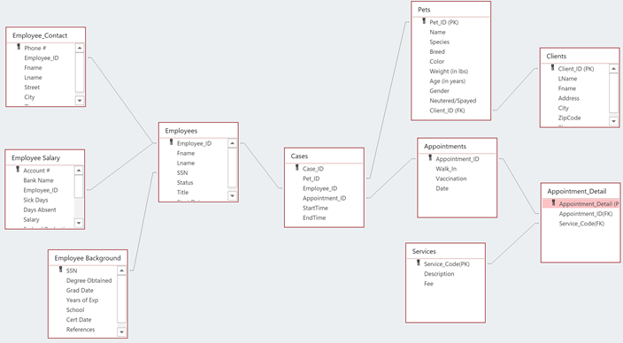

**LOGICAL RELATIONAL SCHEMA**

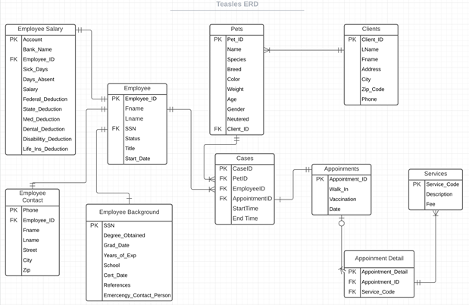

**DATA TABLES**

*See attached Excel file for complete breakdown of tables with full data input*

**QUERIES/RESULTS**

1. Names of groomers and their clients, and number of times each client was groomed.

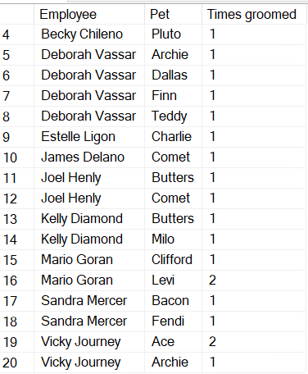

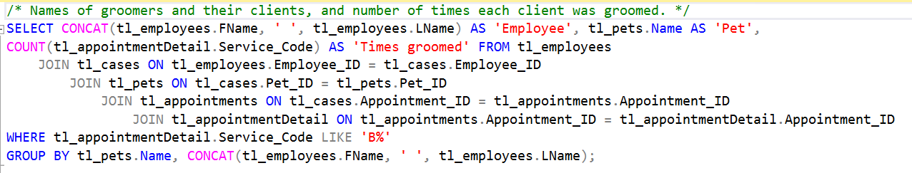

1. Names of clients not seen in the last year and date last seen.

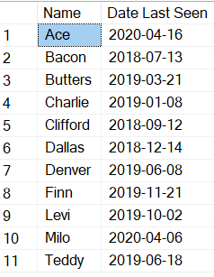

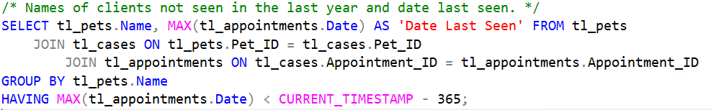

1. Services performed on animals most often (by species)

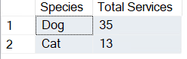

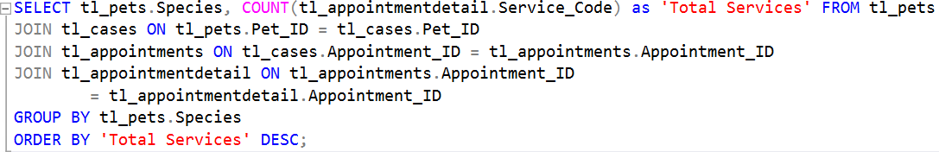

1. Which pets had walk-in service more than once?

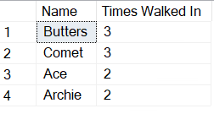

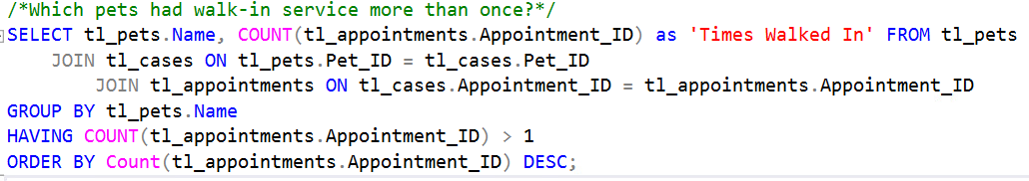

1. A listing of Pets and their owner in decreasing order by number of grooming visits

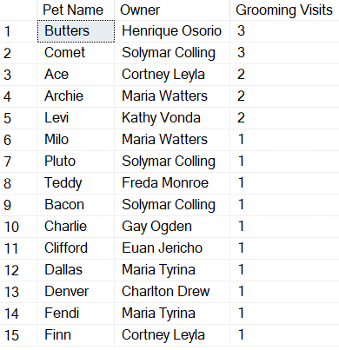

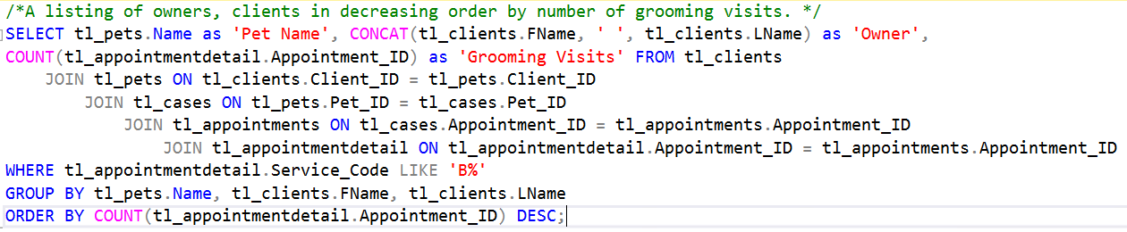

1. Names of animals that have been turned away because of lack of required vaccinations.

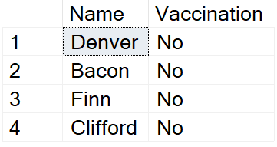

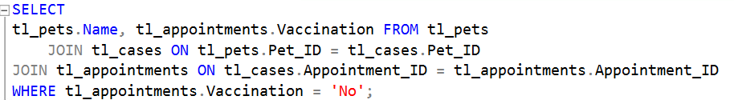

1. The name of the pet that has been groomed most often



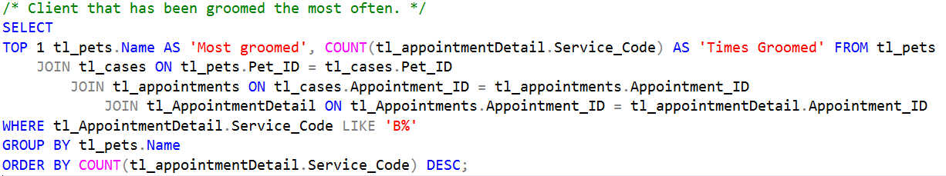

1. Which employees earn more than the average salary for all employees?

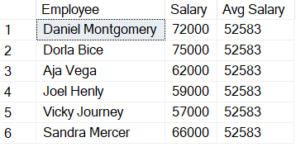

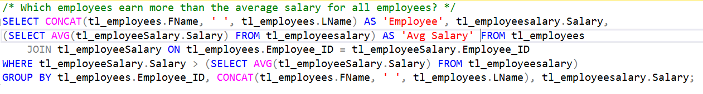

1. Which part time employee has been with Teasles the longest?



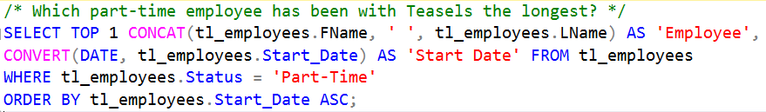

1. Which employee has the most sick days?



**ISSUES/QUIRKS/CHALLENGES**

There were a few challenges:

-- Identifying the number and structure of the tables per the client need

-- What was to be designated as primary and foreign keys

-- Making sure the data was uniform for identical columns across tables

**LESSONS LEARNED**

Some of the lessons learned were that:

-- Relationship references must be established in proper order

-- The correct type of data (VARCHAR, INT, etc.) must always be applied for good results

-- Paper-file systems are far inferior to a well-structured database system

**APPENDICES**

**A.**

CREATE TABLE tl_clients (

[Client_ID] INT PRIMARY KEY,

[LName] NVARCHAR(7),

[Fname] NVARCHAR(8),

[Address] NVARCHAR(30),

[City] NVARCHAR(13),

[Zip_Code] INT,

[Phone] NVARCHAR(14)

);

CREATE TABLE tl_pets (

[Pet_ID] INT PRIMARY KEY,

[Name] NVARCHAR(8),

[Species] NVARCHAR(3),

[Breed] NVARCHAR(16),

[Color] NVARCHAR(7),

[Weight] INT,

[Age] INT,

[Gender] NVARCHAR(1),

[Neutered] NVARCHAR(3),

[Client_ID] INT FOREIGN KEY REFERENCES tl_clients(Client_ID)

);

CREATE TABLE tl_employeebackground (

[SSN] NVARCHAR(11) PRIMARY KEY,

[Degree_Obtained] NVARCHAR(14),

[Grad_Date] DATETIME,

[Years_of_Exp] INT,

[School] NVARCHAR(15),

[Cert_Date] DATETIME,

[References] NVARCHAR(12),

[Emercengy_Contact_Person] NVARCHAR(14)

);

CREATE TABLE tl_employees (

[Employee_ID] INT PRIMARY KEY,

[Fname] NVARCHAR(7),

[Lname] NVARCHAR(10),

[SSN] NVARCHAR(11),

[Status] NVARCHAR(9),

[Title] NVARCHAR(7),

[Start_Date] DATETIME

FOREIGN KEY (SSN) REFERENCES tl_employeebackground(SSN)

);

CREATE TABLE tl_employeesalary (

[Account] INT PRIMARY KEY,

[Bank_Name] NVARCHAR(8),

[Employee_ID] INT,

[Sick_Days] INT,

[Days_Absent] INT,

[Salary] INT,

[Federal_Deduction] NUMERIC(3, 2),

[State_Deduction] NUMERIC(3, 2),

[Med_Deduction] NUMERIC(3, 2),

[Dental_Deduction] NUMERIC(3, 2),

[Disabilitiy_Deduction] NUMERIC(3, 2),

[Life_Ins_Deduction] NUMERIC(3, 2)

FOREIGN KEY (Employee_ID) REFERENCES tl_employees(Employee_ID)

);

CREATE TABLE tl_employeecontact (

[Phone] NVARCHAR(12) PRIMARY KEY,

[Employee_ID] INT,

[Fname] NVARCHAR(7),

[Lname] NVARCHAR(10),

[Street] NVARCHAR(17),

[City] NVARCHAR(9),

[Zip] INT

FOREIGN KEY (Employee_ID) REFERENCES tl_employees(Employee_ID)

);

CREATE TABLE tl_appointments (

[Appointment_ID] INT PRIMARY KEY,

[Walk_In] NVARCHAR(3),

[Vaccination] NVARCHAR(3),

[Date] DATE

);

CREATE TABLE tl_services (

[Service_Code] NVARCHAR(3) PRIMARY KEY,

[Description] NVARCHAR(41),

[Fee] NUMERIC(3, 1)

);

CREATE TABLE tl_appointmentdetail (

[Appointment_Detail] NUMERIC(3, 1) PRIMARY KEY,

[Appointment_ID] INT FOREIGN KEY REFERENCES tl_appointments(Appointment_ID),

[Service_Code] NVARCHAR(3) FOREIGN KEY REFERENCES tl_services(Service_Code)

);

CREATE TABLE tl_cases (

[Case_ID] INT PRIMARY KEY,

[Pet_ID] INT FOREIGN KEY REFERENCES tl_pets(Pet_ID),

[Employee_ID] INT FOREIGN KEY REFERENCES tl_employees(Employee_ID),

[Appointment_ID] INT FOREIGN KEY REFERENCES tl_appointments(Appointment_ID),

[StartTime] TIME,

[EndTime] TIME

);

INSERT INTO tl_clients VALUES

(1,N'Vonda',N'Kathy',N'9505 Pereza Via',N'Lexington, NE',68850,N'(858) 780-9237'),

(2,N'Leyla',N'Cortney',N'8515 Costa Verde Blvd',N'Lexington, NE',68850,N'(858) 352-6837'),

(3,N'Watters',N'Maria',N'9645 Genesee Ave',N'Lexington, NE',68850,N'(858) 453-9199'),

(4,N'Colling',N'Solymar',N'8662 Lake Ashmere Dr',N'Lexington, NE',68850,N'(619) 461-0745'),

(5,N'Ogden',N'Gay',N'8333 Clairemont Mesa Blvd #200',N'Lexington, NE',68850,N'(442) 749-8438'),

(6,N'Jericho',N'Euan',N'8737 Lake Murray Blvd',N'Lexington, NE',68850,N'(619) 713-0942'),

(7,N'Drew',N'Charlton',N'10724 Cariuto Ct',N'Lexington, NE',68850,N'(858) 598-5938'),

(8,N'Monroe',N'Freda',N'1111 Reed Ave',N'Lexington, NE',68850,N'(858) 352-6160'),

(9,N'Osorio',N'Henrique',N'10754 Glendover Ln',N'Lexington, NE',68850,N'(858) 578-0994'),

(10,N'Tyrina',N'Maria',N'10840 Las Mayas Via',N'Lexington, NE',68850,N'(858) 672-4176');

INSERT INTO tl_pets VALUES

(1,N'Pluto',N'Dog',N'Goldendoodle',N'Brown',40,1,N'M',N'Yes',4),

(2,N'Milo',N'Cat',N'Scottish Fold',N'White',15,6,N'M',N'Yes',3),

(3,N'Denver',N'Dog',N'Golden Retriever',N'Golden',60,9,N'F',N'No',7),

(4,N'Levi',N'Dog',N'Poodle',N'White',14,4,N'F',N'Yes',1),

(5,N'Finn',N'Cat',N'Siamese Cat',N'Gray',15,7,N'M',N'No',2),

(6,N'Ace',N'Dog',N'Chihuahua',N'White',5,7,N'M',N'No',2),

(7,N'Butters',N'Dog',N'Rotweiller',N'Black',130,10,N'F',N'Yes',9),

(8,N'Bacon',N'Dog',N'German Shepherd',N'Black',50,12,N'F',N'Yes',4),

(9,N'Comet',N'Cat',N'Maine Coon',N'Cream',10,14,N'F',N'Yes',4),

(10,N'Teddy',N'Dog',N'French Bulldog',N'Tan',25,6,N'M',N'Yes',8),

(11,N'Charlie',N'Dog',N'French Bulldog',N'Brindle',30,4,N'M',N'Yes',5),

(12,N'Clifford',N'Dog',N'Siberian Husky',N'Black',52,11,N'M',N'Yes',6),

(13,N'Fendi',N'Dog',N'Maltipoo',N'White',17,8,N'F',N'Yes',10),

(14,N'Dallas',N'Cat',N'Scottish Fold',N'Black',12,9,N'M',N'Yes',10),

(15,N'Archie',N'Dog',N'German Shepherd',N'Black',80,10,N'M',N'Yes',3);

INSERT INTO tl_employeebackground VALUES

(N'623-87-8957',N'Accounting','2010-05-19 00:00:00',8,NULL,NULL,NULL,NULL),

(N'349-84-8975',N'Business Admin','2015-12-20 00:00:00',5,NULL,NULL,NULL,NULL),

(N'541-87-6523',NULL,NULL,11,N'Jonas Institute','2009-04-22 00:00:00',NULL,NULL),

(N'748-36-8974',NULL,NULL,10,N'Collins School','2010-02-01 00:00:00',NULL,NULL),

(N'246-82-7531',NULL,NULL,9,N'Jonas Institute','2013-07-25 00:00:00',NULL,NULL),

(N'235-45-0325',NULL,NULL,1,N'Collins School','2019-11-15 00:00:00',NULL,NULL),

(N'698-85-5486',NULL,NULL,15,N'Collins School','2004-09-12 00:00:00',NULL,NULL),

(N'963-85-4257',NULL,NULL,4,N'Collins School','2016-03-13 00:00:00',NULL,NULL),

(N'354-89-7895',NULL,NULL,2,N'Jonas Institute','2017-10-10 00:00:00',NULL,NULL),

(N'365-21-5477',NULL,NULL,4,N'Jonas Institute','2014-05-06 00:00:00',NULL,NULL),

(N'210-54-2509',NULL,NULL,NULL,NULL,NULL,N'988-962-7852',N'Maria Conaway'),

(N'587-69-5103',NULL,NULL,NULL,NULL,NULL,N'987-870-1260',N'Helen Shayahan');

INSERT INTO tl_employees VALUES

(101,N'Daniel',N'Montgomery',N'623-87-8957',N'Full-Time',N'Office','2016-04-01 00:00:00'),

(102,N'Dorla',N'Bice',N'349-84-8975',N'Full-Time',N'Office','2016-10-01 00:00:00'),

(103,N'Aja',N'Vega',N'541-87-6523',N'Full-Time',N'Groomer','2017-03-01 00:00:00'),

(104,N'Joel',N'Henly',N'748-36-8974',N'Full-Time',N'Groomer','2020-05-01 00:00:00'),

(105,N'Vicky',N'Journey',N'246-82-7531',N'Full-Time',N'Groomer','2018-09-01 00:00:00'),

(106,N'Deborah',N'Vassar',N'235-45-0325',N'Full-Time',N'Groomer','2020-04-01 00:00:00'),

(107,N'Sandra',N'Mercer',N'698-85-5486',N'Full-Time',N'Groomer','2016-04-01 00:00:00'),

(108,N'Kelly',N'Diamond',N'963-85-4257',N'Full-Time',N'Groomer','2019-05-01 00:00:00'),

(109,N'Mario',N'Goran',N'354-89-7895',N'Full-Time',N'Groomer','2019-11-01 00:00:00'),

(110,N'James',N'Delano',N'365-21-5477',N'Full-Time',N'Groomer','2019-06-01 00:00:00'),

(111,N'Becky',N'Chileno',N'210-54-2509',N'Part-Time',N'Cleaner','2017-03-01 00:00:00'),

(112,N'Estelle',N'Ligon',N'587-69-5103',N'Part-Time',N'Cleaner','2017-10-01 00:00:00');

INSERT INTO tl_employeesalary VALUES

(8259878,N'Marcy',101,9,0,72000,0.22,0.07,0.04,0.02,0.02,0.01),

(5879625,N'Coldwell',102,3,4,75000,0.22,0.07,0.04,0.02,0.02,0.01),

(9686588,N'Coldwell',103,14,6,62000,0.2,0.06,0.04,0.02,0.02,0.01),

(6955444,N'Marcy',104,6,1,59000,0.18,0.05,0.04,0.02,0.02,0.01),

(4879036,N'Coldwell',105,4,3,57000,0.18,0.05,0.04,0.02,0.02,0.01),

(4879658,N'Marcy',106,11,3,46000,0.16,0.03,0.04,0.02,0.02,0.01),

(5679160,N'Coldwell',107,1,1,66000,0.2,0.06,0.04,0.02,0.02,0.01),

(1694987,N'Coldwell',108,0,4,50000,0.18,0.05,0.04,0.02,0.02,0.01),

(4812924,N'Marcy',109,4,1,48000,0.16,0.03,0.04,0.02,0.02,0.01),

(8479652,N'Marcy',110,7,2,50000,0.18,0.05,0.04,0.02,0.02,0.01),

(4687911,N'Marcy',111,2,5,24000,0.1,0.02,NULL,NULL,NULL,NULL),

(2610247,N'Coldwell',112,1,3,22000,0.1,0.02,NULL,NULL,NULL,NULL);

INSERT INTO tl_employeecontact VALUES

(N'308-587-5230',101,N'Daniel',N'Montgomery',N'1565 Hickory Lane',N'Lexington',68850),

(N'308-254-4820',102,N'Dorla',N'Bice',N'75 County Ct',N'Lexington',68850),

(N'308-398-0851',103,N'Aja',N'Vega',N'344 Shiloh Dr',N'Lexington',68850),

(N'308-510-5085',104,N'Joel',N'Henly',N'456 Magnolia Ave',N'Lexington',68850),

(N'308-250-8777',105,N'Vicky',N'Journey',N'3465 Tennessee Dr',N'Lexington',68850),

(N'308-984-0580',106,N'Deborah',N'Vassar',N'403 Garden Rd',N'Lexington',68850),

(N'308-541-5847',107,N'Sandra',N'Mercer',N'94 Member Blvd',N'Lexington',68850),

(N'308-699-8815',108,N'Kelly',N'Diamond',N'4 Privet Ln',N'Lexington',68850),

(N'308-597-7752',109,N'Mario',N'Goran',N'509 Golden Place',N'Lexington',68850),

(N'308-230-5079',110,N'James',N'Delano',N'86 Truman St',N'Lexington',68850),

(N'308-210-5225',111,N'Becky',N'Chileno',N'39 Fendi Ln',N'Lexington',68850),

(N'308-163-2805',112,N'Estelle',N'Ligon',N'12 Lyons Ave',N'Lexington',68850);

INSERT INTO tl_appointments VALUES

(151,N'Yes',N'Yes',N'7/13/2018'),

(152,N'Yes',N'Yes',N'09-12-18'),

(153,N'Yes',N'Yes',N'9/17/2018'),

(154,N'Yes',N'Yes',N'12-12-18'),

(155,N'Yes',N'Yes',N'12/14/2018'),

(156,N'Yes',N'Yes',N'01-08-19'),

(157,N'Yes',N'Yes',N'1/22/2019'),

(158,N'No',N'Yes',N'3/21/2019'),

(159,N'Yes',N'No',N'04-16-19'),

(160,N'No',N'Yes',N'06-08-19'),

(161,N'No',N'Yes',N'6-18-19'),

(162,N'Yes',N'Yes',N'08-02-19'),

(163,N'No',N'Yes',N'10-02-19'),

(164,N'Yes',N'Yes',N'11-21-19'),

(165,N'No',N'Yes',N'2/23/2020'),

(166,N'Yes',N'No',N'03-29-20'),

(167,N'No',N'Yes',N'04-06-20'),

(168,N'Yes',N'Yes',N'4/16/2020'),

(169,N'No',N'No',N'5/17/2020'),

(170,N'Yes',N'Yes',N'07-12-20'),

(171,N'Yes',N'Yes',N'09-06-20'),

(172,N'No',N'Yes',N'9/14/2020'),

(173,N'Yes',N'Yes',N'11/21/2020'),

(174,N'Yes',N'No',N'12-28-20'),

(175,N'Yes',N'Yes',N'4/13/2021');

INSERT INTO tl_services VALUES

(N'B1',N'Small Dog, Short Hair',20),

(N'B2',N'Small Dog, Long Hair',25),

(N'B3',N'Medium Dog, Short Hair',30),

(N'B4',N'Medium Dog, Long Hair',45),

(N'B5',N'Large Dog, Small Hair',40),

(N'B6',N'Large Dog, Long Hair',55),

(N'B7',N'X-Large Dog, Small Hair',50),

(N'B8',N'X-Large Dog, Long Hair',65),

(N'B9',N'Mega-Dog, Small Hair',60),

(N'B10',N'Mega-Dog, Long Hair',70),

(N'S1',N'nail trim',8),

(N'S2',N'ear cleaning',5),

(N'S3',N'skin scrape',25),

(N'S4',N'ear mite treatment',10),

(N'S5',N'flea treatment',15),

(N'S6',N'tick treatment',12.5),

(N'S7',N'teeth brushing',8.5),

(N'S8',N'nose & pad conditioning',6),

(N'S9',N'eye cleaning & drops',7.5),

(N'S10',N'hair cut',15),

(N'S11',N'chalking(5 colors available) ',4),

(N'S12',N'stenciling (20 designs, 8 color options) ',7),

(N'S13',N'feathering (6 options available)',5),

(N'S14',N'Vitamins (soft shiny coat)',15),

(N'S15',N'matted hair',30);

INSERT INTO tl_appointmentdetail VALUES

(1.0,151.0,N'B10'),

(2.0,152.0,N'B4'),

(3.0,152.0,N'S1'),

(4.0,153.0,N'B1'),

(5.0,153.0,N'S2'),

(6.0,154.0,N'B10'),

(7.0,154.0,N'S11'),

(8.0,155.0,N'B1'),

(9.0,156.0,N'B3'),

(10.0,157.0,N'B6'),

(11.0,158.0,N'B2'),

(12.0,159.0,N'B5'),

(13.0,159.0,N'S15'),

(14.0,160.0,N'B1'),

(15.0,161.0,N'B4'),

(16.0,162.0,N'B2'),

(17.0,163.0,N'B1'),

(18.0,163.0,N'B4'),

(19.0,163.0,N'S9'),

(20.0,164.0,N'B2'),

(21.0,164.0,N'S15'),

(22.0,164.0,N'S2'),

(23.0,164.0,N'S3'),

(24.0,165.0,N'B8'),

(25.0,165.0,N'S11'),

(26.0,165.0,N'S12'),

(27.0,165.0,N'S4'),

(28.0,167.0,N'B3'),

(29.0,167.0,N'S6'),

(30.0,168.0,N'B2'),

(31.0,168.0,N'S13'),

(32.0,168.0,N'S4'),

(33.0,170.0,N'B3'),

(34.0,170.0,N'S1'),

(35.0,170.0,N'S4'),

(36.0,171.0,N'B7'),

(37.0,171.0,N'S10'),

(38.0,171.0,N'S13'),

(39.0,171.0,N'S14'),

(40.0,171.0,N'S5'),

(41.0,171.0,N'S6'),

(42.0,172.0,N'B6'),

(43.0,172.0,N'S12'),

(44.0,172.0,N'S6'),

(45.0,173.0,N'B6'),

(46.0,173.0,N'S5'),

(47.0,175.0,N'B5'),

(48.0,175.0,N'S11'),

(49.0,175.0,N'S7'),

(50.0,175.0,N'S8');

INSERT INTO tl_cases VALUES

(1,15,105,171,N'10:32',N'20:10'),

(2,7,104,154,N'9:35',N'15:49'),

(3,10,106,161,N'9:30',N'16:44'),

(4,1,111,170,N'15:25',N'16:32'),

(5,6,105,162,N'12:31',N'15:56'),

(6,4,109,163,N'13:41',N'17:01'),

(7,9,104,173,N'11:44',N'18:27'),

(8,15,106,165,N'14:11',N'20:56'),

(9,5,106,164,N'12:02',N'16:07'),

(10,11,112,156,N'9:04',N'10:06'),

(11,8,107,151,N'12:10',N'12:30'),

(12,12,109,152,N'10:35',N'20:15'),

(13,2,108,167,N'11:40',N'11:50'),

(14,6,105,168,N'15:03',N'18:56'),

(15,9,110,172,N'11:30',N'18:42'),

(16,7,108,158,N'12:53',N'19:36'),

(17,13,107,175,N'17:44',N'18:34'),

(18,9,103,157,N'18:48',N'19:37'),

(19,7,111,153,N'9:45',N'12:23'),

(20,3,103,160,N'8:12',N'17:14'),

(21,14,106,155,N'15:32',N'19:54');

**B.**

